|  |  |  |
| --- | --- | --- |
|  | **31ST INFANTRY BATTALION**  **ASSOCIATION INCORPORATED**  **NEWSLETTER 2024** |  |

|  |  |  |
| --- | --- | --- |
| ASSOC PRESIDENT | PATRON |  |
| Greg Stokie | Graham Harris ED (CAPT Rtd) |  |
|  |  |  |
| PRESIDENT | PATRON | PO Box 684 |
| Paul Ellems |  | TOWNSVILLE. QLD. 4810 |
|  |  | Ph/Fax: |
| SECRETARY | WEB ADDRESS | Mobile: 0468 832 837 |
| Jason Kepper | [http://31bnassn.org](http://31bnassn.org/). | Email: [pellems@gmail.com](mailto:pellems@gmail.com) or  secretary.31stbattalion.rqr.assoc@gmail.com |

2025 is half over with many locations having experienced a deluge and flood. We hope the rains and floods missed damaging you. Each year appears to bring its unique challenges.

The main priority in 2024 was the Commemorative Service at St James Cathedral. This will also be our priority this coming year 2025. This will be the eleventh successive Commemorative Service by our association.

It is now time to renew your membership. The membership fee has been retained at $20.

Importantly, could members please supply your email addresses or your mobile numbers when you renew your membership. A phone call or any other method would also suffice. Both an email or a mobile phone number will allow the committee to contact you if there are invitations to extend. The email is important in reducing the costs of sending this newsletter which is expensive to produce.

The hard copy of this newsletter for the mail out is printed only in black and white. If you have received the hard copy and can access an email address, please let me know as we can then send you an electronic copy that is in full colour. The colours on the emblems and the photos really stand out.  
An email address will also allow the committee to extend invites at short notice for BBQs or invitations from military units.

**2024 AGM Townsville Branch Annual General Meeting (AGM)**

The Townsville Branch AGM was held on in Tues 11th March 2024 at 7.30 pm at the conference meeting room Townsville RSL. All the positions for Office Bearers and Committee Members were opened for any nomination. The result of the voting is as below.

**2024 - 31st Battalion (Bn) Association (Assoc) Incorporated, Townsville Branch Management Committee Members.**

|  |  |
| --- | --- |
| President: Paul Ellems. Ph: 0468 862 837.  Email: [pellems@gmail.com](mailto:pellems@gmail.com) | **Committee Members:** |
| Vice president: Gregory Stokie. | Mark Allen |
| Vice President: Jason Kepper | Merv Dicton |
| Vice President: Anthony Creek | Peter Rubiolo |
| Secretary: Jason Kepper |  |
| Treasurer: Gerald Southward |  |
| Fundraising Officer: Darryl Walker. |  |
| Heritage Officer: Lindsay (Stretch) Elmore |  |

The Committee meetings are held at the Townsville RSL on the second Tuesday of each month. All our members are invited and are welcome to attend.

The 2025 AGM was held on Tuesday the 8th of April at 7:30 pm at the Townsville RSL in the conference Rooms. The AGM was originally planned for the second Tuesday in March but had to be postponed because of a lack of a quorum due to various reasons.

All position will be spilled and nominations for any positions are encouraged. Details on that later.

**The Year Past - 2024**

**31/42 Battalion**

The Commanding Officer of 31/42 Battalion is LTCOL Cam KcKay. LTCOL McKay is a Reserve Officer residing in Cairns. His civilian job is with the Queensland Police Service. He is in charge of the Ready Response Group.

The Operations Officer (OPSO) is: MAJ Jeff Martin

The Regimental Sergeant Major (RSM) is: WO1 David Nicholas

Executive Officer: MAJ Mark Smith

**Fundraising in 2024**

We had two fundraising sources in 2024. The raffles at the Cowboys Club, organised by Darryl Walker and the monies from the soft drink can deposits due to the efforts of Kevin Whelan. Darryl Walker’s good relationship with the Cowboys Club has again proved invaluable and scored us the 2025 Australia Day Raffle. Kevin Whelan’s continued contribution to the Association’s funds via his collection of soft drink cans is amazing.   
I have been accompanying him on his collections and recycling trips and am amazed at the links he has with patriotic community members. These community members are friends of Kevin and are committed to the memory of the 31st Battalion soldiers and indeed, all ex-serviceman and serving defence members. Both Darryl and Kev are inspiring. Our thanks go to Darryl and Kevin and their supporters. Behind them stand the Cowboys Club with Clint Williams, the JFM Kebab shop with Mustafa Karratas and other shops and individuals at the Garbutt shopping centre. Without their support to Darryl and Kevin we would not be in the financial position we are. Please support the Cowboys Club if you are in the area. Unfortunately, Mustafa has sold JFM Kababs and the new owners will not support the club. This will dent the can collection but Kevin is looking for other sources.

Darryl is occasionally given the option of a raffle at short notice. Thanks to Paola and Jason Kepper, as well as Darryl as they have been regulars for these short notice events.

This has placed our Association in a very good financial position.

* Cash in Bank 01 Jan 2023 was $12,741.11.
* Closing Bank balance on 31 Dec 2023 was $.14,044.78.
* Our treasurer’s report confirmed this position.

**Status of Members**

Number of financial members at start of 2023: 52

Number of financial members at end of 2023: 29

The reducing membership is disconcerting.

**Commemorative Events 2025.**

The Townsville RSL remains our base for meetings. Each year, they extend a number of invitations due to our Association. These are reflected in the dates listed at the end of this report. These celebrations are an open invitation to all our members to attend and renew old and not so old comrades and friendships.

**Fall of Singapore 15th Feb 2024.**The Townsville Fall of Singapore was conducted at the Townsville RSL. Paul Ellems attended the ceremony, and a book was laid.

**Anzac Day. 25th April 2024.**Anzac Day was very well attended by the public and servicemen. A wreath was laid on behalf of the Association. We marched under the 31st Battalion Association Banner for the first time in many years. 31/42 Battalion always extends an invitation to our Association to attend their commemoration. Greg Stokie (COL Retd) and a number of our members attended and laid a. wreath at the Anzac commemoration at 31/42 at Lavarack.

**Battle of Coral Sea Commemoration at Cardwell 30th Apr 2024**

Neville Hines, Darryl Walker and Paul attended and lay a wreath. Also present were the US Ambassador and a senior US navy offace and the US Navy band.

**31st Battalion Assoc BBQ for members and ex-members. Sun 10 Jul 2023.**

We have held a BBQ at the North Queensland Military Museum (AMNQ) to encourage ex-members to come and share a coffee/sanger, renew aquaintances and also share tall tales and memories.

Chris Cummings has a large photo collection and has given a USB with copious photos that I will gradually insert into newsletters. Thanks Chris.

**Fromelles Day - Tues 20th July 2024**

The commemoration for Fromelle’s Day was again washout this year due to the operational tempo for 31/42 Battalion.

**31st Battalion Commemorative Service – Sun 18th Aug 2024**

The year’s Commemorative Service was held at St James Cathedral. The Service was low key the pattern for previous years with morning tea at the Cathedral. The Commanding Officer was not able to attend but the RSM, David Harding WO1, and the Battalion soldiers again supported the service. The Battalion Colours were proudly on display. Our immense thanks to the RSM and his soldiers for his support. Their support and presence gives the military significance to the commemoration and makes the whole difference to the atmosphere for the day. Thank also to the Anglican Bishop and the Dean of St James Cathedral and the parishioners for their continued support for our association.

A special thanks to Greg Stokie for organising this service and to Kevin Blackford for his many years of playing the Last Post for this service.

**National Serviceman’s Commemoration.**Paul Ellems is still a member of the National Serviceman’s Association Townsville Branch. Many of the ex-31 RQR members were National Servicemen. Paul has been acting as the MC at the National Serviceman’s Commemoration Service at Rose Bay on 30th June. A plaque is placed for each National Serviceman who has passed away during the year. Sadly, the numbers in their association are diminishing very quickly. Both the National body and the State Management committees are considering closing.

**Personal Celebrations for Members**

On the 19th of Jan 2024, Norm Snell of the Charters Towers Branch celebrated his 100th birthday. There was a Shire Council ceremony where Norm planted a native tree beside the highway into Charters Towers. Congratulations to Norm and well done to the Charters Towers Branch for organising this celebration.

**Charters Towers**

The branch had an opening ceremony for the Tunnellers graves on 19th oct 2024. The original grave markers were a wrought iron numbered plate. An ignomonious way to mark a returned serviceman’s grave, especially for one who suffered the horrors of combat in the tunnels. Great credit must go to three people in particular. The local historian, Donna Baldey, for her efforts in identifying the soldiers and their war records and bringing it to the attention of Vic Nicol and Ray Barrett. Credit also goes to Vic and Ray for ensuring that these soldiers were acknowledged. A thank you to the artist, Michael Meszaros, who allowed a copy of his work to be used on the headstones.

**Performance against the Association Aims for 2024.**

Below are the Association’s Aims and the results:

* 31st Battalion Assoc Commemorative Service – Sunday 18th August 2024. Done.
* Attend the Commemorative events on RSL invites as part of the Associations commitment to honour particular, historical military events. Done.
* BBQs and social events to renew and encourage comradeship. BBQs are planned for the Army Museum of North Queensland and for ex-members in Ayr, Bowen, and Proserpine.The BBQ’a did not eventuate. However, for the Ayr,Bowen Airlie Beach ex-31 soldiers a lunch was organised at the Ayr Soldiers club. This occurred on XXXX. Unfortunately, only two ex-31 soldiers from the Ayr area attended. There were 9 Townsville members who attended.
* Hold a members Dinner towards the end of the year. Not done.
* Email Minutes of monthly meetings to members with email addresses. Not done.
* Offer two to three bursaries of $300 to descendants of 31 Bn ROR Association members and serving soldiers of 31/42 Bn RQR. Done. The sad and confusing outcome of this effort was that we did not receive one application.
* Offer automatic Associate membership to serving 31/42 soldiers. Done but not communicated to 31/42 soldiers yet.
* Complete the negotiations with AMNQ to sell on our behalf: Done.
  + the 31 RQR coolers. Coolers are on sale for $10.
  + The new fabric emblems. We are retaining these for our sales at the moment.
  + 31 RQR Badges. We are retaining these for our sales.
* Begin sponsorship of 4TTT. This is now ongoing. 4TTT play a recorded message about our association three times per day. This sponsorship will also advertise our annual commemoration service.

**The Year Ahead – 2025**

**Association Aims for 2025**

Below are the Association’s Aims:

* 31st Battalion Assoc Commemorative Service – Sunday 18th August 2025.

For 2026, a preliminary approach has been made to the Governor of Queensland and her Aide-de-camp regarding her ability to attend the 2026 Commemoration. The Governor indicated that she would love to attend. As it stands we may have her attend the Commemoration Service but not in an official, formal presence. She will be in Townsville for the VP80 celebrations.

* Attend the Commemorative events on RSL invites as part of the Associations commitment to honour particular, historical military events.
* BBQs and social events to renew and encourage comradeship.
* Hold a members Dinner towards the end of the year.
* Email Minutes of monthly meetings to members with email addresses.
* Offer two to three bursaries of $500 to descendants of 31 Bn ROR Association members and serving soldiers of 31/42 Bn RQR.
* Offer automatic Associate membership to serving 31/42 soldiers.
* Continue sponsorship and advertising of 4TTT.
* Possible donation to the Army Museum of North Queensland.

**Fundraising in 2025**

The raffles at the Cowboy’s Club were very successful in 2024. The Cowboy’s support has been crucial in achieving such a strong financial position. All members and interested persons are welcome to attend and assist. Darryl often obtains extra dates as they become available, and members of the committee have supported this at short notice. These events and recycling monies are vital if we are to continue to support memorial ceremonies and our community activities.

**31st Battalion (Royal Queensland Regiment) Association Townsville Branch Annual General Meeting**

The AGM was held in Tues 8th April 2025 at which Paul stood down and all the positions on the committee were spilled. All positions voted on.

The results are:

**31st Battalion Association Committee Members**

|  |  |
| --- | --- |
| * **President:** Paul Ellems | **Committee Members:** |
| * **Vice President 1:** Gregory Stokie | Andrew Gill |
| * **Vice President 2:**  Jason Kepper | Mark Allen |
| * **Vice President 3:** Anthony Creek | Merv Dicton |
| * **Secretary:** Jason Kepper | Peter Hall |
| * **Treasurer**: Gerald Southward | Peter Rubiolo |
| * **Fundraiser**  Darryl Walker |  |
| * **Heritage Officer:** Lindsay Elmore |  |

The QLD Association AGM had their AGM immediately after the Townsville Branch AGM.

**31st Battalion Commemorative Service – Sun 17th August 2025.**

This year’s Commemorative Service will be held at St James Cathedral on Sun 17th Aug 2025. The Service will follow the pattern for previous years with morning tea in the Cathedral. 31/42nd Battalion have already indicated that they will support this celebration.

This year may be significant because it is being held as part of the VP80 Celebrations. The Queensland Governor, Her Excellency the honourable Jeanette Young AC PSM, will be in Townsville for VP80 and has indicated that she will be attending the service.

We also plan to formally invite her to the commemoration in 2026.

Our thanks to Greg Stokie for organising the event.

The address is: St James Cathedral, 36 Cleveland Terrace, Townsville City QLD 4810.  
Alternatively, you could use this link in Google Maps: [VIEW IN GOOGLE MAPS](https://goo.gl/maps/5n9ap3gNuPdw2W3s9)

**Members and friends of the Battalion.**

We intend to continue to hold get-together BBQs to foster the old friendships within previous members of 31st Battalion. The location at the Army Museum North Queensland (AMNQ) has been excellent and the Museum staff has been great in their support. There are many ex-members of the 31st Bn that would enjoy the opportunity of renewing friendships and memories.

We are aware that some of our members may need assistance. I extend an invitation to our members to let us know if you need assistance with. We can either help directly or put you in touch with resources that may be able to assist you.

**RSL ceremonies 2025.**

The RSL includes our Association as an invite to these ceremonies. All members are invited to attend and participate. We sent a request to the RSL and the Townsville City Council for inclusion as a unit in the Anzac Day march. We did march in 2024 and 2025.

**Fromelle’s Day - Sunday 20th July 2025**

This is normally conducted at Lavarack on an invitation from 31/42 Bn RQR. We do not have an indication on the status of this celebration with the 31/42 Battalion for 2025.

The Ipswich RSL is holding their Battle of Fromelles on Saturday the 19th Jul 2025. It will be held at the Honour Stone, Ipswich Memorial Hall, 63 Nicholas Street, IPSWICH. QLD.

The link in Google Maps is: [VIEW IN GOOGLE MAPS](https://goo.gl/maps/Ei66opuaZqTfgqSH9)

Our Brisbane members and the Ipswich RSL are doing a great job supporting this commemoration.

**Monthly Meetings.**

All members are invited to our monthly meetings on the second Tues of each month at the Townsville RSL in the Boardroom. It is the intention to begin sending the minutes of the minutes to all members who have an email address.

**Reunion Dinner/Luncheon 2025**

It is planned that we have a Reunion Dinner/Luncheon this year. I will send out further details when we decide on a date and venue.

**Bursaries for 2025**

This decision is seen as a way of giving back to the 31 Bn membership and their families, and the community as a whole. The original modest quantum of $300 has been increased to $500 and is intended to assist in the education of the successful applicants. The Bursary could be used for school or tertiary or trade training.

**Serving soldiers of 31/42 Bn**

A decision was made to include all serving members of 31/42 Bn as automatic associate membership of 31st Bn Association however they will need to individually apply for the membership.

**Army Museum of North Queensland (AMNQ)**Having 31 Bn Coolers and Fabric emblems on sale at the Museum would be a way of obtaining some modest funds from their sale as well as publicising the role of 31st Bn and indeed all NQ Army Reserve units in the Jezzine Barracks/Kissing Point history. Unfortunately there has been few sales at this venue.

**4TTT Sponsorship.**

Sponsorship of 4TTT will allow the Association to have regular advertisements on Association’s aims, meetings, and our future events. The sponsorship appears to be worthwhile and will continue.

**Ingham and Charters Towers and Brisbane Branches**Activities for the Ingham and Charters Towers Branches will be advised as they come to hand. If you plan to be in Brisbane, please contact Tony Wadeson on 0427 337 177. You will be most welcome. Most of their functions are held at the Sherwood Services Club right next to the Corinda Station.

**The Whispering Boomerang**

Martin O’Sullivan continues as co-ordinator of “The Boomerang” website. Thanks Martin. If you have photos and articles about an event, please write a few paragraphs and forward it to Greg Stokie or Paul Ellems. The web address for the Whispering Boomerang is: [http://31bnassn.org](http://31bnassn.org/). It is recommended as a good source of information about the Battalion and its members.

**Commemorative Services and Important dates for remaining for 2023.**

A comprehensive list of dates for 2025-26 are included at the end of this newsletter.

**Renewal Membership 2025 and new members**

A reminder that the annual subscription is now due, and the cost has remained at $20.00.

Please fill in the form if you are new or need to update us with a new address or ph number or email address.

We have kept the subscription at the same level for many years. The modest $20 membership is used for Incorporation fees and for insurance premiums when we are undertaking Association business or events. Through the efforts of Darryl Walker, Kevin Whelan, Greg Stokie, and the assistance of Paola and Jason Kepper, Anthony Creek and others, we have been able to retain the subscription at such a low level and still continue with the Association’s NQLD presence for ceremonies and helping members.

**Finally, we hope to see you at our gatherings, have a great and safe 2025.**

|  |  |
| --- | --- |
|  |  |
| Mr Paul Ellems | Jason Kepper |
| President | Secretary |
| 31 Bn Assoc Inc | 31 Bn Assoc Inc |
| Townsville Branch | Townsville Branch |

**Merchandise.**

* We have new embroidered cloth Emblems with gold lettering for $20.00. It is about the size of a shirt pocket. See below.

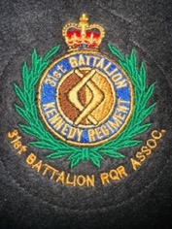

* Some 31st Bn Assoc printed ties are available for $25.
* We have new 31st Bn, Royal Queensland Regiment (RQR) Assoc metal lapel badges. The badge writing in the photo does not do the badge justice. The writing in reality is very concise, and very legible. The colour is a deep chocolate and yellow, not black as the LH photo shows. They are available for $25.00.   
  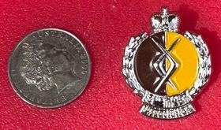



* Stubby coolers. The coolers are $10 each. Below is the face on the cooler with all the battalion’s battle honours.

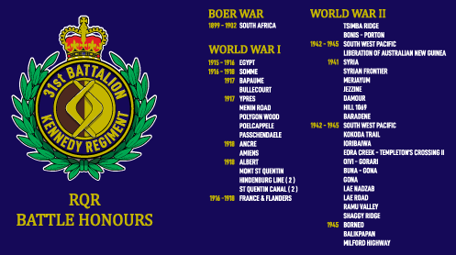

* LOGO Stickers that can be affixed to almost anything. ($5)

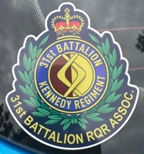

**Commemorative Services and Significant dates for 2025/26**

**All members are welcome to attend our mthly meetings - second Tues each mth RSL Townsville.**

|  |  |
| --- | --- |
| **01 Jan 1901** | **Commonwealth of Australia proclaimed** |
| 26 Jan 2025. | Cowboys Raffle |
| 26 Jan 2025. | Australia Day. NB. First Landing 29 Apr 1770. Claimed 22 Aug. |
| **Tues 11 Feb 2025.** | **First Assoc meeting for 2025.** |
| Wed 14 Feb 2025. | National Serviceman Day |
| Sat 25th April 2025. | ANZAC DAY |
| 08 May 2025. | Victory in Europe. 1945. |
| Sat 08-10 Jun 2025 | Battle of Porton 1945. 31/51 Bn. 31/42 Bn & 51st Bn Assoc’s & 35 Water Tpt Sqn. |
| Thurs 12 Jun 2025 | Blackhawk helicopter tragedy High Range (1996) |
| Mon 30 Jun 2025. | **\***National Servicemen’s Commemoration Day. |
| Tues 01 Jul 2024. | Reserve Forces Day |
| Sat 19 Jul 2025. | Fromelle’s Day. 19 Jul 1916. 5,500 cas. 2,000 dead. 400 captured. Commemoration at IPSWICH RSL. |
| Fri 15th Aug 2025. | **RSL.**  Victory in the Pacific (VP) Day 1945 |
| Mon 18 Aug 2025. | * **RSL.**  Vietnam Veterans’ Day |
| **Sun 17 Aug 2025** | **31st Battalion Association Commemorative Church Service** |
| Sun 07 Sept 2025. | Father’s Day |
| Mon 06 Oct 2025. | King’s Birthday – QLD. |
| **Fri 31st Oct 2025.** | **31st Battalion Birthday** |
| **Sun 09 Nov 2025.** | **Cowboys Raffle Day.** |
| Mon 11th Nov 2025. | **\* RSL.**  Remembrance Day |
| Tues 12th Nov 2024. | 31st Assoc Meeting. Possible penultimate meeting |
| 23 Nov 2025 | Birthday 1,2,3 RAR. Formed 1948. |
| Tues 9th Dec 2024. | 31st Assoc Meeting. Possible last 31st Bn Assoc meeting for 2025 |
| Dates TBA. | 31st Battalion (RQR) Assoc Formal Dinner |
| Wed 18 Dec 2025**.** | **\***Texas Terror Commemoration in Ingham. |
| Tues 10th Feb 2026 | **!st meeting for 31st Bn Assoc 2026. (Prepare for AGM in April 2026)** |
| Tues 15th Apr 2026. | **Tentative 31st Bn Assoc 2026 AGM Meeting** |

PHOTOS

**Photos of the card from the King Charles and Queen Camilla for Norm Snell’s 100th Birthday. Charters Towers Branch.**

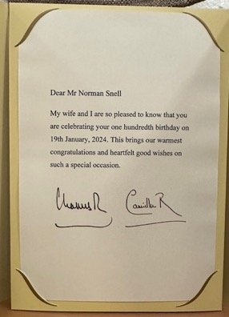 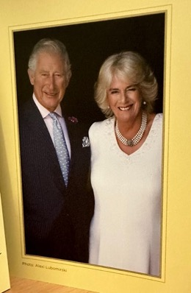

**2024.01.19. On occasion of celebration of Norm Snell’s 100th Birthday with a tree planting. Norm Arriving and dignitaries. In the RH photo Norm is seated in the front row, the 2nd from the left.**

**Standing on the far left is Vic Morrow and on the far right is Ray Barrett, Charters Towers President.**

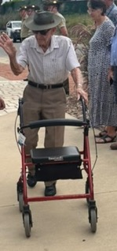 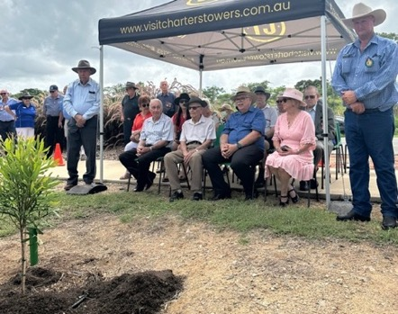

09 Mar 2024. The current 31st Inf Bn Assoc Marching Banner. Sadly aged and spoiled.

Impossible to clean as the printing is vulnerable. We think it needs replacing. Any ideas?

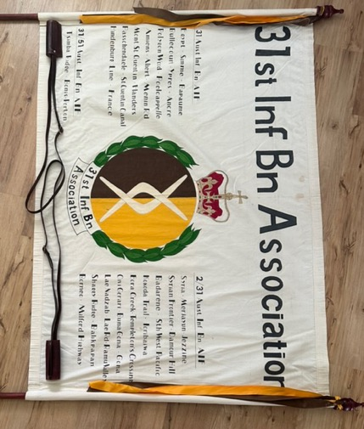

12 March 2024. A earlier Banner that has been discovered. Front side.

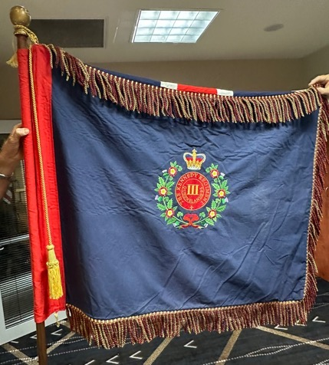

Reverse Side

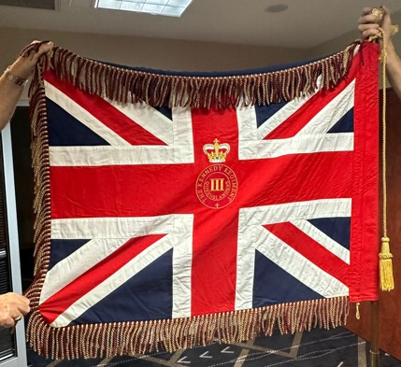

8 Dec 2024. Committee lunch. L to R. Cheryl Cummings, Chris Cummings, Maaurie DeGiovanni, Darriel Walker.

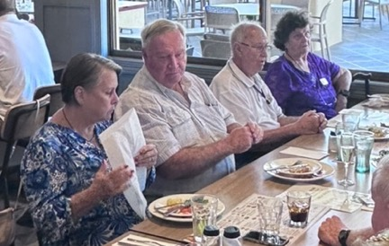

8 Dec 2024. Committee lunch. L to R. Merv Dicton, Lindsay (Stretch) Elmore

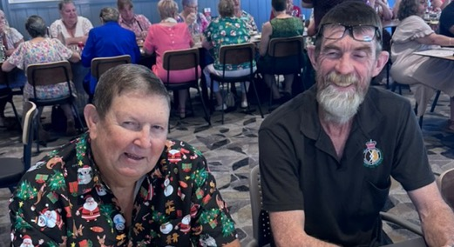

8 Dec 2024. Committee lunch. L to R. Dale Graw, Mark Smith OPSO 31/42 Bn, Mark Allen, Jeanette Allen, Jeanette Stokie.

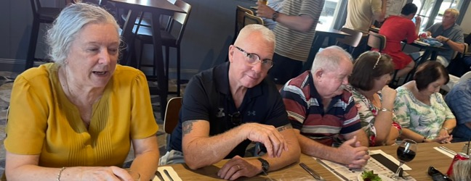

8 Dec 2024. Committee lunch. Steven Graw (COL Retd)



19 Oct 2024. Ceremony for the new headstones on the Tunnellers’ graves.   
L to R: Donna Baldey, Felix Reitano OAM, Vic Nicoll, Greg Stokie (COL Retd), Paul Ellems, Ray XXX President Charters Towers Branch.

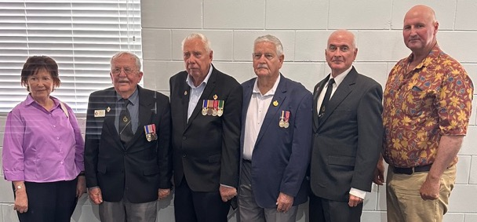

19 Oct 2024. Ceremony for the new headstones on the Tunnellers’ graves. Original Grave site marker for a tunneler in Charters Towers Cemetery.

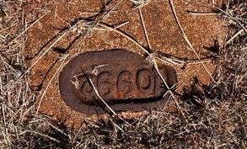

19 Oct 2024. Ceremony for the new headstones on the Tunnellers’ graves. The grave site with the new headstone.

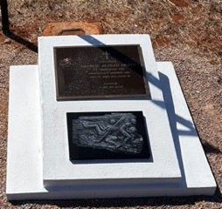

19 Oct 2024. Ceremony for the new headstones on the Tunnellers’ graves. The plaque, honouring the tunnellers, is affixed to each headstone.

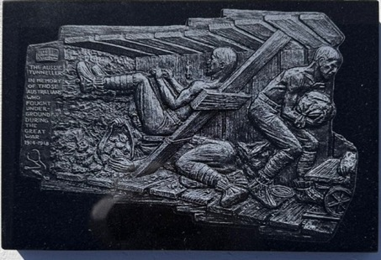

13 Oct 2024.

Jason Kepper, Mark Smith OPSO 31/42 Bn, Ewan Cameron President Rollingstone RSL, Taken during the “Vets Health and WellBeing Weekend” on the property owned by Damien Green, Ex-CO 31/42 Bn.

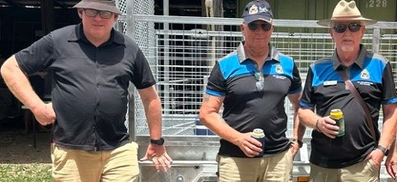

13 Oct 2024. Paul Ellems, Jason Kepper, Damien Green Ex CO 31/42 Bn. On Damien’s property.

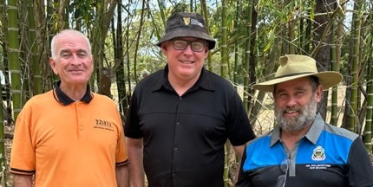

18 Aug 2024. 31st Bn Assoc Commemorative Service. Darryl Walker, Lindsay Elmore (Stretch), Andrew Gill.

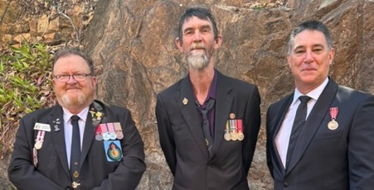

18 Aug 2024. 31st Bn Assoc Commemorative Service. Arthur Bosworth, Chris Cummings.

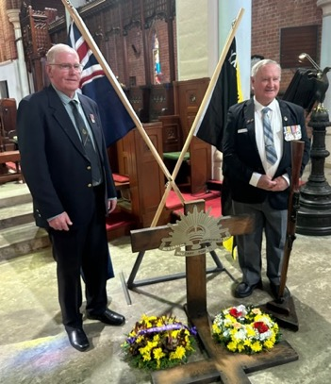

18 Aug 2024. 31st Bn Assoc Commemorative Service. 31st Bn Assoc Combined.

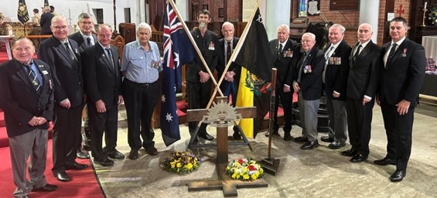

18 Aug 2024. 31st Battalion RQR (The Kennedy Battalion) Association Commemorative Service. 11 BRIGADE OFFICERS. L to R. MAJ Daniel Farrands. LT Alexaner de Campo,

CPL Kenton Harvie, RSM 31/42 RQR WO1 David Nicholas,

COMD 11 BDE BRIG Rishard Pease, A/RSM 11 BDE WO1 Ryan Snell, LT Joshua Bourquin,

CPL Jackson Pearson, PTE Hugo Boyd (Bugler)

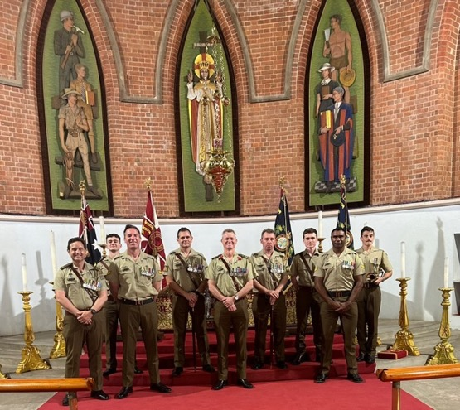

5 May 2024 Battle of Coral Sea at Cardwell. L to R. John Hardy OAM Secretary 51st Ban Assoc, Paul Ellems, Neville Hines President National Servicemen Assoc and also a member of our Assoc.

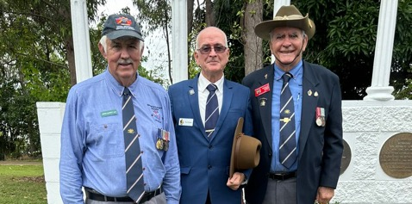

Anzac Day 25 April 2024. L to R. Lady unknown please Advise. Les Tilker, Andrew Gill,

Lindsay Elmore (Stretch), Anthony Creek, Gould RAAF, Jason Kepper, David Pincinelli,

Paul Ellems

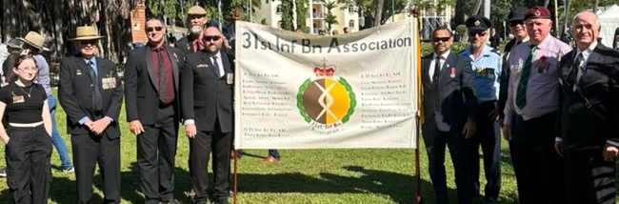

Anzac Day 25 April 2024.

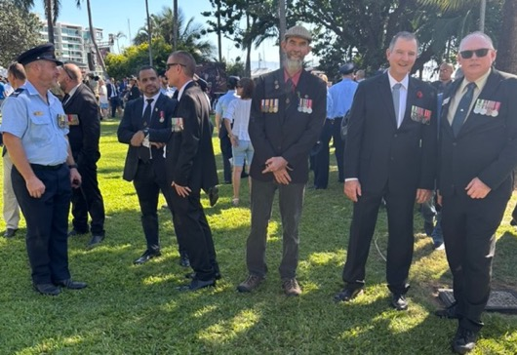

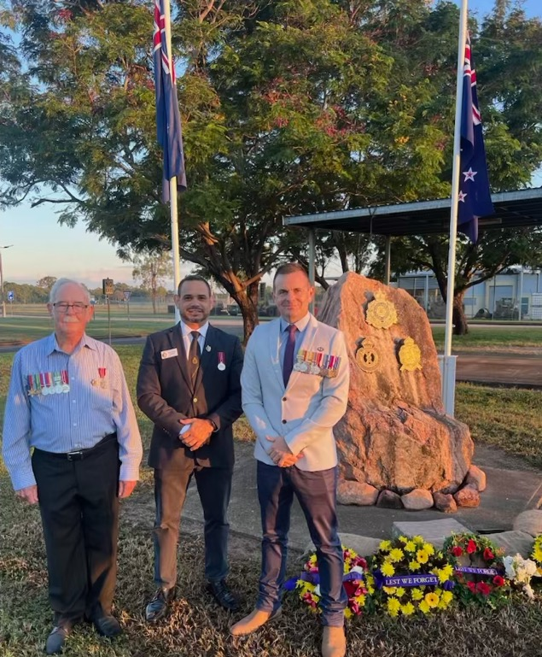

**MEMORIES**

If you have any photos of past exercises or groups of comrades please submit them to Paul.

1982 Command Group 31st Independent Rifle Coy. L to R. CAPT Arthur Bosworth,

MAJ Chris Cummings, CAPT Angus Moxham (ARA) ADJT.

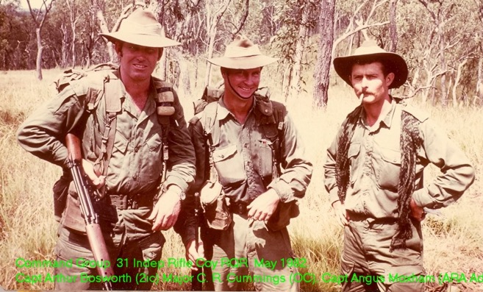

**FOR ANY PAYMENTS: Please include your name as Identification.**

**Without any identifying ID, we have no way of tracing the source of the payments and allocating them to a member.**

|  |  |  |
| --- | --- | --- |
|  | **31st INFANTRY BATTALION ASSOCIATION INC.**  **TOWNSVILLE BRANCH**  **APPLICATION FOR MEMBERSHIP/ASSOCIATE MEMBERSHIP** |  |

**Membership is open to serving and ex-serving members of 31 RQR and its sister battalions,**

**as well as members of the public or other units who have an affinity for the Association.**

**SURNAME: _______________________GIVEN NAMES: _______________________________**

**EMAIL (Important for future contact.): ____________________________________________**

**PHONE: _____________________________MOBILE: __________________________________**

**STREET: ________________________________________________________________________**

**SUBURB: ______________________________ STATE: __________POSTCODE: ___________**

**CURRENTLY SERVING: Y / N. UNIT: _________________________________________**

**RANK: ____________REGIMENTAL NO: __________________DOB: ______/______/_______**

**BRIEF RECORD OF SERVICE or LINK TO THE BATTALION (Optional):**

**SIGNATURE OF APPLICANT: ____________________________DATE: __________________**

**$20 Payment Direct Debit (Preferred). Reference: Please include your name.**

National Australia Bank. BSB: 084-766 Account Number: 57-874-2457

Account Name: 31st Infantry Battalion Association Inc. Townsville.

**Payments by Mail: Again: Please include your name.**

$20 Cheques, Money Orders (Made out to the 31st Inf. Bn. Assn. Inc.) or cash may be enclosed and mailed to:

The Secretary, 31st Infantry Battalion Association (Inc)  
PO Box. 684

TOWNSVILLE. QLD. 4814

|  |  |  |
| --- | --- | --- |
|  | **31ST BATTALION**  **ROYAL QUEENSLAND REGIMENT**  **(THE KENNNEDY BATTALION)**  **ASSOCIATION INC**. |  |

**EDUCATION QUEENSLAND BURSARIES FOR – 2025**

If you are a financial ex-31st Battalion Association member or a Widow or widower of an ex-31st Battalion member, or a current financial supporter or a current serving member of the 31/42 Battalion and you have a child, grand child or great grandchild who has just completed year ten or eleven, please consider having them apply for our bursary. If you are a serving member of 31/42 Battalion who is undertaking trade training or tertiary studies, you could also consider seeking the support of this bursary.

Two/three Bursaries valued at $500 each, will be awarded on the results obtained in Education and training in Queensland to support continuing education or training. The Bursaries will be awarded to entrants, in order of merit, as decided by the Executive Committee of the 31st Battalion Association, Townsville Branch.

To be eligible you must be:

* A descendant or a person under guardianship of a current Financial Member of the 31st Battalion Association or of a Widow of a former member of the 31st Battalion Associationor,
* A current serving member of the 31/42 Battalion and is a financial member of our Association.

The selection criteria will include:

* Results in grades 10, 11 or 12, or tertiary education results or, trade training.
* Activities undertaken within the community such as sporting or charities or social club work.
* A short essay on your aspirations for life and within the community.
* Finally, there may be a personal interview with the applicants and their sponsor.

**APPLICATIONS WILL CLOSE ON THE 30th OCTOBER, 2025.**

Gregory Stokie  
President   
31st Inf Bn RQR Assoc Inc.

|  |  |  |
| --- | --- | --- |
|  | **31ST BATTALION**  **ROYAL QUEENSLAND REGIMENT**  **(THE KENNNEDY BATTALION)**  **ASSOCIATION INC**.  **BURSARY APPLICATION** |  |

Full name of applicant:………………………………………….………………………………….

Address:……………………………………………………………………….……………………………….

……………………………………………………………………………………….……………………………….

Email address: ……………………………………………..…ph no: ………………………………

Educational institution/s :……………………………………………………………….………

……………………………………………………………………………………….……………………………….

Educational level:……………………………………………………………………..……………….

Full name of sponsor (ex-serving 31st Bn parent or grand-parent or serving member):

……………………………………………………….……………………………………………………………..

Service no:…………………………..branch of service:………………………………….....

Signature of applicant:

………………………………………..………. Date:……………………………………….

Signature of sponsor – e.g. Parent: or grand-parent:

……………..……………………………………. ………………………………………………………….

Please attach supporting documents and return the application and the essay to the Postal Address below or electronically to the Email Address.

31st Battalion RQR (The Kennedy Battalion) Assoc. Inc.

PO Box 684

TOWNSVILLE.

QLD. 4810

EMAIL: [pellems@gmail.com](mailto:pellems@gmail.com)